Jonathan Simonin

Bookwork #2

Professor Wei

CSE 2100

From pg 525

11.1: If we insert the five entries in order into an empty binary search tree we should get a tree that has the root as a (1,A) with children (2,B) on the left and (3,C) on the right. The Nodes (4,D) would be added as a child of (3,C) and (5,E) would be the right child of (2,B).

11.3: Assuming I’m understanding the question correctly it wants to know how many binary search trees can be made from inserting the keys {1,2,3} – and the result is 5 different ways.

11.4: There are several solutions to prove the Dr. wrong, one of which is to draw the tree that gets created by inputting numbers 3,5,7,9,11,13. Now draw a new tree that gets created when the 5 and 9 are switched in the input order so you get 3,9,7,5,11,13.

11.5: Yet again Dr. Amongus is incorrect, inserting the entries say 3,5,7 is not the same as inserting 5,3,7.

11.7: The rotation in figure 11.11 is a double trinode restructuring. The structuring in figure 11.13 is a single reconstruction.

11.11: The net effect of the height of the rebalanced subtree due to the operation is that the tree ends up becoming balanced. Without the AVL implementation of a tree, a binary search tree ends up becoming unbalanced after a while you’ll see that one subtree’s height is much shorter than the other subtree of the root. With an AVL tree you never see this effect, the maximum height difference between subtrees is only 1 at max.

11.13: There might be a problem restoring the AVL property with a misaligned x node because the node x requires that it has the has the greatest height and must be one higher than y node.

* 11.17: According to the following definitions, figure 11.22a does not follow the format of a 2,4 tree. A (2,4) tree (also called 2-4 tree or 2-3-4 tree) is a multi-way search with the following properties
  + Node-Size Property: every internal node has at most four children
  + Depth Property: all the external nodes have the same depth

11.19: If we add to a 2,4 tree in different orders then we will not have the same tree. If we insert the numbers 1 to 5 into a tree in the following orders we could end up with : 1,2,3,4,5 or 2,3,4,5,1. The following charts show the results we can have:

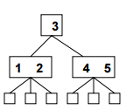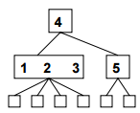

11.21:

A.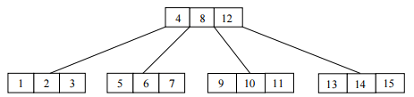

B. 